**2018 Rocky Mountain Woodturning Symposium**

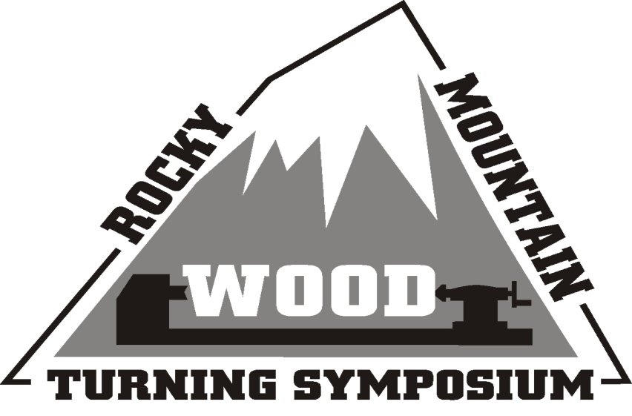

**Online Registration Now Open**

**Go to** [**rmwoodturningsymposium.com**](http://rmwoodturningsymposium.com/) **for more information and registration.**

The Rocky Mountain Woodturners are happy to announce our annual woodturning symposium to be held on September 14, 15 and 16, 2018.  It will once again be at The Ranch/Larimer County Fairgrounds, Loveland, Colorado. Since space is limited, we encourage everyone to register early.

Check in starts on Friday, September 14th, from 1 until 5:30 PM. The first rotation will be on Friday at 3:30pm. Meet and greet the demonstrators on Friday, 6-8 PM, at the Loveland Woodcraft store. There will be over 42 excellent demonstrations during the weekend from demonstrators, vendors and hands on turning. Featured demonstrators include **Mike Mahoney, Dale Larson, Jason Breach, Sally Ault, Merryll Saylan, Brian Gisi, Joe Fleming, Trent Bosch, Micheal Roper, and Doug Schneiter*.***  Also included is a large trade show, woodturners gallery, banquet, and live auction Saturday evening conducted by a professional auctioneer. The rotation schedule has been already been posted, so [check the website for up-to-date information](http://rmwoodturningsymposium.com).

Registration is now open, with a discount if postmarked by August 15th.  Don’t wait space is limited. We hope you can join us. It is a great opportunity to meet fellow Woodturners in a relaxing environment while you learn the latest techniques from some of the best Woodturners in the field. [Visit the website for more details and instructions regarding registration](http://rmwoodturningsymposium.com). It will be continually updated as details are finalized.

Rocky Mountain Woodturning Symposium

September 14, 15 and 16, 2018

The Ranch/Larimer County Fairgrounds

Loveland, Colorado

[rmwoodturningsymposium.com](http://rmwoodturningsymposium.com/)